**AWS Scenario based Interview Questions**

**QuestionScenario:-**

EC2 instances fail to launch with Autoscaling configuration  
  
**Description :-**   
Autoscaling configuration requires the following :-  
  
Autoscaling launch configuration which allows you to select an

* + AMI
  + Instance type
  + IAM role (optional)
  + Security group
  + Key pair file

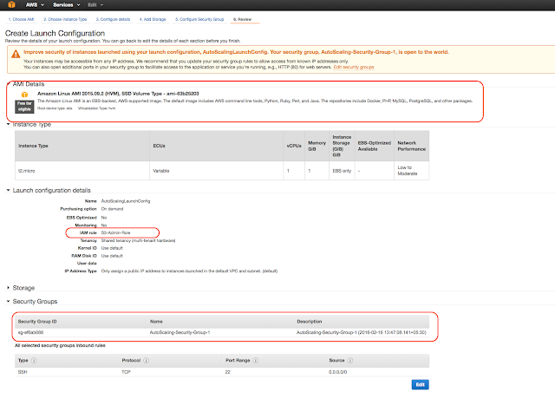

Autoscaling group configuration allows you to select AZ to be used to launch the EC2 instances with the selected launch configuration

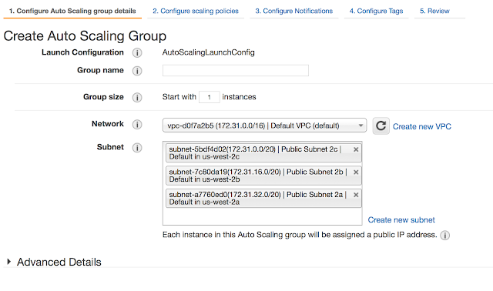

**Troubleshooting key points :-**

1. AMI id does not exist or is still pending and cannot be used to launch instances
2. Security group provided in the launch configuration does not exist
3. Key pair associated with the EC2 instance does not exist
4. Autoscaling group not found or is incorrectly configured
5. AZ configured with the Autoscaling group is no longer supported cause it might not be available
6. Invalid EBS block device mappings
7. Instance type is not supported in the AZ
8. Capacity limits reached either cause of the [restriction](https://aws.amazon.com/ec2/faqs/) on the number of instance type that can be launched in a region or cause AWS is not able to provision the specified instance type in the AZ (for e.g. no more spot instances or On-demand instances availability)

**Question:**

I have some private server on my premises, also I have distributed some of my workload on the public cloud, what is this architecture called?

**Solution**:

It is Hybrid Cloud

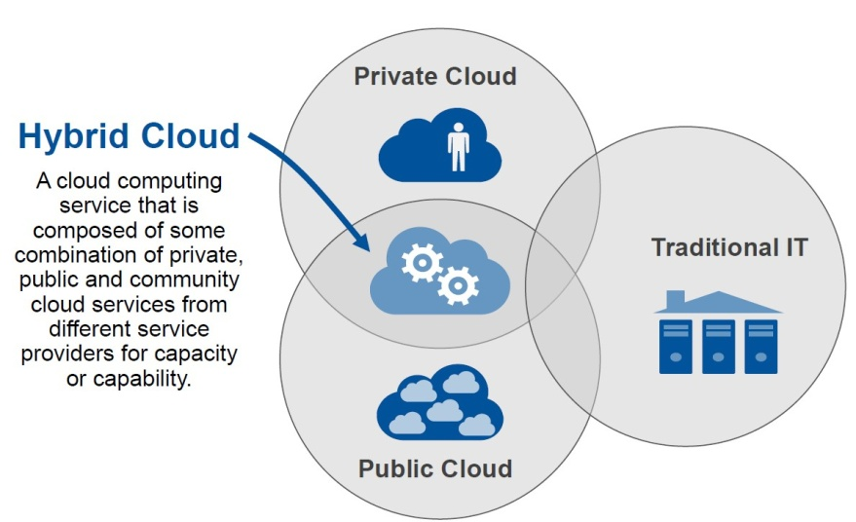

This type of architecture would be a hybrid cloud. Why? Because we are using both, the public cloud, and your on premises servers eg:., the private cloud. To make this hybrid architecture easy to use, wouldn't it be better if your private and public cloud were all on the same network (virtually). This is established by including your public cloud servers in a virtual private cloud, and connecting this virtual cloud with your on premise servers using a VPN(Virtual Private Network)

**How is stopping and terminating an instance different from each other?**

Starting, stopping and terminating are the three states in an EC2 instance, let’s discuss them in detail:

* **Stopping and Starting** an instance: When an instance is stopped, the instance performs a normal shutdown and then transitions to a stopped state. All of its Amazon EBS volumes remain attached, and you can start the instance again at a later time. You are not charged for additional instance hours while the instance is in a stopped state.
* **Terminating** an instance: When an instance is terminated, the instance performs a normal shutdown, then the attached Amazon EBS volumes are deleted unless the volume’s *deleteOnTermination* attribute is set to false. The instance itself is also deleted, and you can’t start the instance again at a later time.

### ****How is a Spot instance different from an On-Demand instance or Reserved Instance?****

First of all, let’s understand that Spot Instance, On-Demand instance and Reserved Instances are all models for pricing. Moving along, spot instances provide the ability for customers to purchase compute capacity with no upfront commitment, at hourly rates usually lower than the On-Demand rate in each region. Spot instances are just like bidding, the bidding price is called Spot Price. The Spot Price fluctuates based on supply and demand for instances, but customers will never pay more than the maximum price they have specified. If the Spot Price moves higher than a customer’s maximum price, the customer’s EC2 instance will be shut down automatically. But the reverse is not true, if the Spot prices come down again, your EC2 instance will not be launched automatically, one has to do that manually.  In Spot and On demand instance, there is no commitment for the duration from the user side, however in reserved instances one has to stick to the time period that he has chosen.

**A customer wants to leverage Amazon Simple Storage Service (S3) and Amazon Glacier as part of their backup and archive infrastructure. The customer plans to use third-party software to support this integration. Which approach will limit the access of the third party software to only the Amazon S3 bucket named “company-backup”?**

A custom IAM user policy limited to the Amazon S3 API in “company-backup”.

**Explanation:** Taking queue from the previous questions, this use case involves more granular permissions, hence IAM would be used here.

### ****Can S3 be used with EC2 instances, if yes, how?****

Yes, it can be used for instances with root devices backed by local instance storage. By using Amazon S3, developers have access to the same highly scalable, reliable, fast, inexpensive data storage infrastructure that Amazon uses to run its own global network of web sites. In order to execute systems in the Amazon EC2 environment, developers use the tools provided to load their Amazon Machine Images (AMIs) into Amazon S3 and to move them between Amazon S3 and Amazon EC2.

Another use case could be for websites hosted on EC2 to load their static content from S3.

**How is Amazon RDS, DynamoDB and Redshift different?**

* Amazon RDS is a database management service for relational databases,  it manages patching, upgrading, backing up of data etc. of databases for you without your intervention. RDS  is a Db management service for structured data only.
* DynamoDB, on the other hand, is a NoSQL database service, NoSQL deals with unstructured data.
* Redshift, is an entirely different service, it is a data warehouse product and is used in data analysis.

**Question:**

 Your company’s branch offices are all over the world, they use a software with a multi-regional deployment on AWS, they use MySQL 5.6 for data persistence.

The task is to run an hourly batch process and read data from every region to compute cross-regional reports which will be distributed to all the branches. This should be done in the shortest time possible. How will you build the DB architecture in order to meet the requirements?

**Solution**:

For each regional deployment, use RDS MySQL with a master in the region and a read replica in the HQ region**.**

For this we will take an RDS instance as a master, because it will manage our database for us and since we have to read from every region, we’ll put a read replica of this instance in every region where the data has to be read from. Option C is not correct since putting a read replica would be more efficient than putting a snapshot, a read replica can be promoted if needed  to an independent DB instance, but with a Db snapshot it becomes mandatory to launch a separate DB Instance.

**ScenarioBased Question**

You are running a news website in the eu-west-1 region that updates every 15 minutes. The website has a worldwide audience it uses an Auto Scaling group behind an Elastic Load Balancer and an Amazon RDS database. Static content resides on Amazon S3, and is distributed through Amazon CloudFront. Your Auto Scaling group is set to trigger a scale up event at 60% CPU utilization; you use an Amazon RDS extra-large DB instance with 10.000 Provisioned IOPS its CPU utilization is around 80%. While freeable memory is in the 2 GB range. Web analytics reports show that the average load time of your web pages is around 1.5 to 2 seconds, but your SEO consultant wants to bring down the average load time to under 0.5 seconds. How would you improve page load times for your users?

**Solution**

Lower the scale up trigger of your Auto Scaling group to 30% so it scales more aggressively.

**2. Add an Amazon ElastiCache caching layer to your application for storing sessions and frequent DB queries**

**3. Configure Amazon CloudFront dynamic content support to enable caching of re-usable content from your site**

4. Switch Amazon RDS database to the high memory extra-large Instance type

5. Set up a second installation in another region, and use the Amazon Route 53 latency-based routing feature to select the right region.

**How will you access the data on EBS in AWS ?**

Elastic block storage as the name indicates provides persistent, highly avaialble and high performance block level storage that can be attached to a running EC2 instance. The storage can formatted and mounted as a file system or the raw storage can be accessed directly

**Differentiate between vertical and horizontal scaling in AWS.**

The main difference between vertical and horizontal scaling is the way in which you add compute resources to your infrastructure. In vertical scaling, more power is added to the existing machine while in horizontal scaling additional resources are added into the system with the addition of more machines into the network so that the workload and processing is shared among multiple devices. The best way to understand the difference is imagine that you are retiring your Toyota and buying a Ferrari because you need more horsepower. This is vertical scaling. Another way to get that added horsepower is not to ditch the Toyota for the Ferrari but buy another car. This can be related to horizontal scaling where you drive several cars all at once.

When the users are up to 100, an EC2 instance alone is enough to run the entire web application or the database until the traffic ramps up. Under such circumstances when the traffic ramps up, it is better to scale vertically by increasing the capacity of the EC2 instance to meet the increasing demands of the application. AWS supports instances up to 128 virtual cores or 488GB RAM.

When the users for your application grow up to 1000 or more, vertical cannot handle requests and there is need for horizontal scaling which is achieved through distributed file system, clustering, and load balancing.

**Scenario**

An organization wants to deploy a two-tier web applications on AWS.  The application requires complex query processing and table joins. However, the company has limited resources and requires high availability. Which is the best configuration that company can opt for based on the requirements ?

**Solution**:

DynamoDB deals with core problems of database scalability, management, reliability, and performance but does not have the functionalities of a RDBMS. DynamoDB does not render support for complex joins or query processing or complex transactions.  You can run a relational engine on Amazon RDS or EC2 for this kind of a functionality.

**How can you safeguard EC2 instances running on a VPC ?**

AWS Security groups associated with EC2 instances can help you safeguard EC2 instances running in a VPC by providing security at the protocol and port access level. You can configure both INBOUND and OUTBOUND traffic to enables secured access for the EC2 instance.AWS security groups are much similar to a firewall-they contain set of rules which filter the traffic coming into and out of an EC2 instance and deny any kind of unauthorized access to EC2 instances.

**How many EC2 instances can be used in a VPC ?**

There is a limit of running up to a total of 20 on-demand instances across the instance family , you can purchase 20 reserved instances and request spot instances as per your dynamic spot limit region.

**What happens when you reboot an EC2 instance?**

Rebooting an instance is just similar to rebooting a PC. You do not return to image’s original state, however, the contents of the hard disk are same as before the reboot.

**In VPC with private and public subnets, database servers should ideally be launched into which subnet?**

With private and public subnets in VPC, database servers should ideally launch into private subnets.

**What Is The Way To Secure Data For Carrying In The Cloud?**

**Answer :**

One thing must be ensured that no one should seize the information in the cloud while data is moving from point one to another and also there should not be any leakage with the security key from several storerooms in the cloud. Segregation of information from additional companies’ information and then encrypting it by means of approved methods is one of the options.

**Explain Stopping, Starting, And Terminating An Amazon Ec2 Instance?**

**Answer :**

**Stopping and Starting an instance:** When an instance is stopped, the instance performs a normal shutdown and then transitions to a stopped state. All of its Amazon EBS volumes remain attached, and you can start the instance again at a later time. You are not charged for additional instance hours while the instance is in a stopped state.

**Terminating an instance:** When an instance is terminated, the instance performs a normal shutdown, then the attached Amazon EBS volumes are deleted unless the volume’s deleteOnTermination attribute is set to false. The instance itself is also deleted, and you can’t start the instance again at a later time.

**Explain Elastic Block Storage? What Type Of Performance Can You Expect? How Do You Back It Up? How Do You Improve Performance?**

**Answer :**

EBS is a virtualized SAN or storage area network.  That means it is RAID storage to start with, so it’s redundant and fault tolerant.  If disks die in that RAID you don’t lose data.  Great! It is also virtualized, so you can provision and allocate storage, and attach it to your server with various API calls. No calling the storage expert and asking him or her to run specialized commands from the hardware vendor.

Performance on EBS can exhibit variability.  That is, it can go above the SLA performance level, then drop below it.  The SLA provides you with an average disk I/O rate you can expect. This can frustrate some folks, especially performance experts who expect reliable and consistent disk throughout on a server.  Traditional physically hosted servers behave that way. Virtual AWS instances do not.

Backup EBS volumes by using the snapshot facility via API call or via a GUI interface like elasticfox.

Improve performance by using Linux software raid and striping across four volumes.